**Module-3: Docker – I Assignment – 2**

**To Do :**

● Save the image created in Assignment 1 as a Docker image

● Launch container from this new image and map the port to 81

● Go inside the container and start the apache2 service

● Check if you are able to access it on the browser

**Solution :**

**Creating a custom docker image from Container created in Assignment 1.**

sudo docker excc -it f5dda5c1cb99 bash //Going inside container

*Creating a custom image out of container* : *sudo docker commit <container ID> <dockerhub url>/<image tag> :-*

sudo docker commit f5dda5c1cb99 sindevops/img_01

//sha256:c1ff285bc66872ef96955046533a5c7050109f529f440fddcac59aeeea8967a8

Sudo docker images // Image Saved - sindevops/img_01 latest c1ff285bc668 About a minute ago 218MB (This img_01 image has each and every service/facilities of the container which we created in assignment 1[Blueprint of container])

sudo docker run –itd –p 81:80 sindevops/img_01 //running a container out of this img_01 image.

// 6ee192e06ccbb2728d615ba40a29b8d98cc3f3a7abfc152134773e6258ce25bc

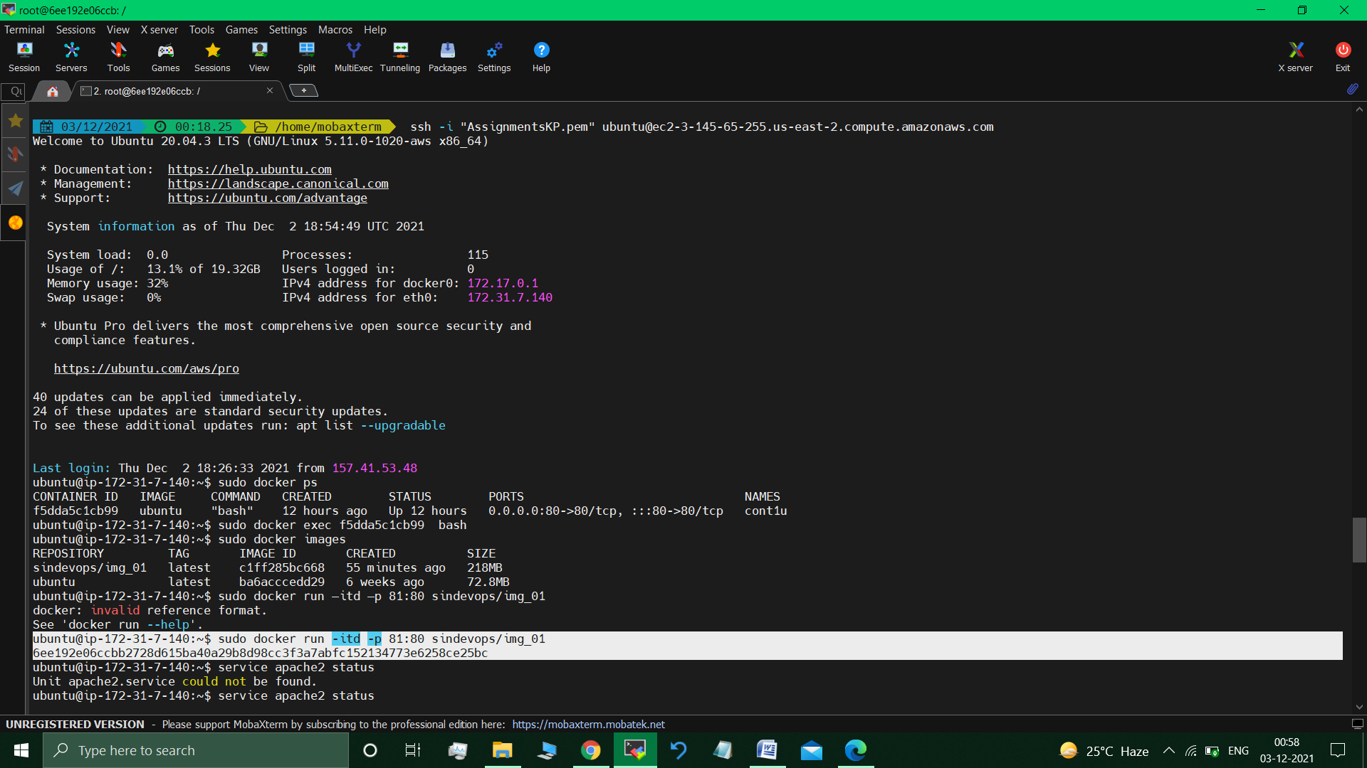

sudo docker exec -it 6ee192e06ccbb2728d615ba40a29b8d98cc3f3a7abfc152134773e6258ce25bc bash //going inside the custom container

service apache2 status //apache2 is not running

service apache2 start //started apache2

**Enabled the All Traffic port**

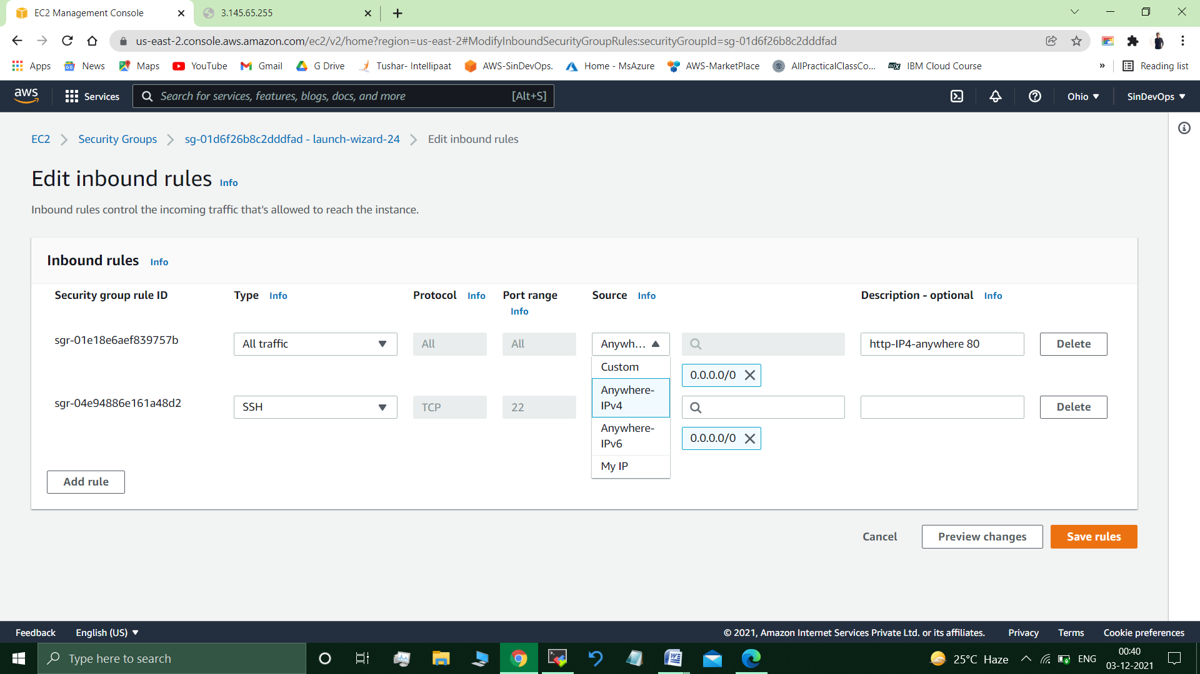

**Accessing apache2 server –**

Google searched the <public IP address : 81 >

<http://3.145.65.255:81/>

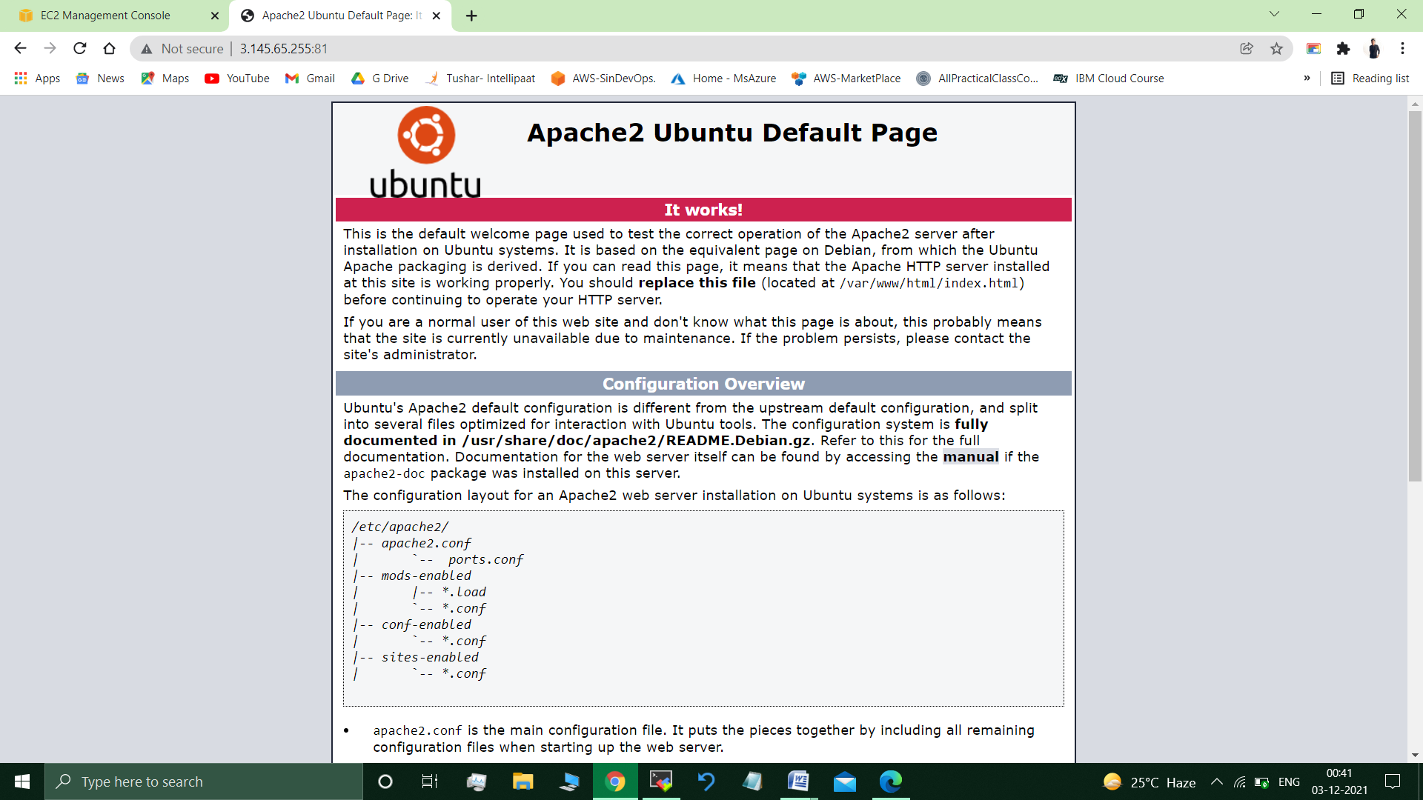

//Apache2 web server available/accessible.

**Submitted By : Tushar Sinha**

**Email ID :** [**sinhatushar17@gmail.com**](mailto:sinhatushar17@gmail.com)

**Enrolled in the “DevOps Architect Master’s Training Program”**